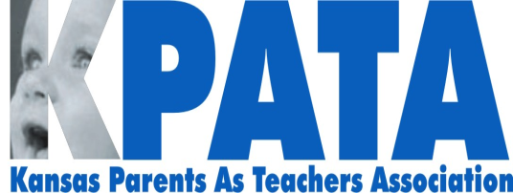
Full Board Meeting
June 10, 2014 – 1 pm-3pm

Roll Call

Treasurer’s Report
- The time deposit savings needs to be approved to roll over or take some money out of it. We have $21,929 in our Savings account on which we can write several checks per year. We have $53,642 balance in our checking account. I have about $1500 worth of travel and time to turn in on to KPATA. We have Christina each month for about $150/month. And we have the Conference coming up. We will have to make a down payment at the hotel for I think ½ of our bill which right now is $9000 so we will need about $5000 which we have in checking.
- Add non profit filing fee of $40
- Buy a new quick books if Christina can’t get it working in Olathe. $250.00

KCCTO/KPATA Collaboration

KHF –meeting with Erik and Debbie from KHSA to look at dates for our 6 regional trainings in Sept. or Oct. Our meeting is June 18, 9-11. I would like to have 2-3 dates from each Regional rep for the meeting in their area.

Early Childhood Mental Health project with KHSA –Maybe a Board member would like to attend the meetings.

With July 1st just around the corner, how do you want to handle those who are joining KPATA now? Do we want to count this into the next year since it’s less than a month away?

Trainings
- PFS and Goal Setting Training in Western Kansas, need help advertising.

Conference Update: Report on Jill Molli, She will be the luncheon keynote March 3 and breakout sessions in the afternoon.

